**Metaverse in E-Commerce:**

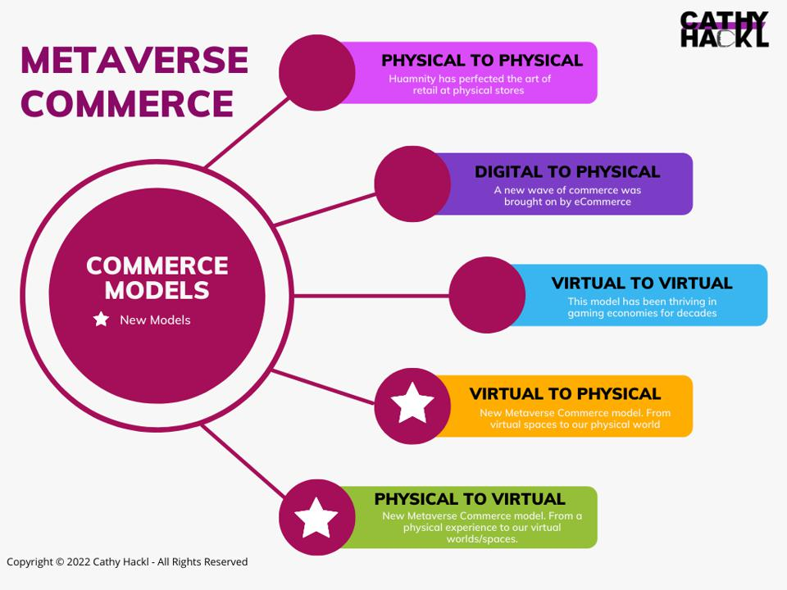

E-commerce (electronic commerce) is the buying and selling of products and services or the transfer of data and funds over the internet. These are business transactions that occur in ways such as business to business (B2B), business to consumer (B2C), consumer to consumer (C2C) or consumer to business (C2B).

Since the option to purchase goods over the internet was first introduced via technology, there has been a fixed divide between the real and digital worlds. This was the case until the introduction of the metaverse, a combination of multiple technologies, built to work together.

This includes a series of technologies such as augmented reality (AR), virtual reality (VR), non-fungible tokens (NFTs) and even games. The metaverse enables multi-modal interactions with digital items, virtual environments, and real people, thus providing an immersive multi-user experience for anyone accessing it around the globe.

The metaverse is all about [‘customer experience’,](https://www.livemint.com/companies/news/it-is-crucial-for-indian-firms-to-get-ready-for-the-metaverse-kulmeet-bawa-11658252682055.html) which covers practices like ‘stronger engagement’ and ‘better understanding of customers’.

According to a survey conducted by Shopkick, 70% of customers believe the ability to try, touch and see products are the main aspects of an in-store experience.

This is going to be solved and fulfilled in the metaverse, as AR and VR allow the same to happen, all from the comfort of your home. Companies would benefit hugely from the metaverse, as it not only widens their consumer base but also has the potential to get reviews on new products, thus pointing them in the right direction for the future.



The metaverse can also bridge the gap between the physical and virtual world, hence merging online and offline commerce into one. This means that users will be able to experience the [physical world](https://www.livemint.com/news/world/sports-metaverse-debuts-virtual-land-sale-11657800574046.html)via the metaverse, digitally, making online shopping more special.

**Some Use Cases:**

Many e-commerce giants have already begun to incorporate the metaverse into their platforms.

* For instance, Amazon has introduced an AR room tool, called ‘room decorator’, which enables the user to see how furniture and/or other decorative items would look in your house.
* Similarly, Flipkart, on April 28th 2022 announced the launch of ‘Flipkart Labs’, designed to “develop blockchain and metaverse use cases", including stores. Furthermore, retail chains like Warby Parker have created virtual fitting apps, allowing the user to try every pair of glasses in its catalogue before its purchase.
* Even clothing brands such as Adidas and Gucci are exploring metaverse stores. This makes online shopping feel personalized and more special, something that has never existed before the metaverse.
* E-commerce in the metaverse is guaranteed to [accelerate + expand](https://www.livemint.com/news/world/kpmg-forays-into-metaverse-invests-30m-for-employee-training-11656486881283.html)over the next few years. As new technology begins to get discovered, new features also usher in allowing online commerce and offline commerce to merge.
* The recent surge of interest in AR and VR ensures the quality and fit of a product prior to purchasing. Normally, e-commerce platforms work in a “browse, choose, click to buy" process.



However, the metaverse will change this to “browse, experience to buy". This means the customers experiencing the metaverse will be able to walk around a store, view product displays, and later make purchases, all from the comfort of their own homes.

**Benefits of Metaverse in E-Commerce:**

* The metaverse has the ability to improve and revolutionize current e-Commerce practices and provide a unique experience for the users. The first benefit of metaverse-powered e-commerce will be ‘personalized experiences', which are often limited to product recommendations + discounts today. In the metaverse, however, brands will be able to offer hyper-personalized ‘browse and buy’ experiences to their customers, eliminating the boundaries present in the physical world.
* The second benefit can be ‘reduced return rates’, since the metaverse-powered e-commerce will help customers try out products before ordering/purchasing them, and the enhanced product visualization will ensure users make informed choices.
* The third benefit will be ‘increased conversion rates and higher upsell’ for traffic/visitor landing on an e-Commerce platform, due to the personalized experience the metaverse would provide.



Recent studies show how people are ready to overpay by almost 40% for a product that can be tested in 3D. All these accrued benefits will finally result in ‘increased profitability' for brands, thus revolutionizing the way they operate.

In conclusion, the metaverse can completely revolutionize the operating model, customer experience, sales, and profitability of ecommerce companies. The key will be how brands embrace and adopt these technologies for creating ‘wow’ experiences for their customers in the future.